05-02-2020

Academic quiz website

CS39440

Edel Sherratt - eds | Version 1 Release

G400 - Computer Science

Rhs24

## Project Description

The project will be a website that young people will be able to go onto and complete gamified quizzes. The quizzes will be simple questions that look and feel more like a game, allowing a younger person to enjoy doing the questions, students in primary school will be the main aim of the website. The quiz will be aimed towards young people and will allow teachers to see how a student is getting on. The scores of the students will need to be saved and viewable on different computers, allowing a user to keep track of data. A login service will also need to be used. This will allow students to log in with their accounts so that scores are kept correctly, teachers will also need to be logged in and view data. A guest account is another account that can be used as well. The questions will be based on maths questions, based on the game mode that they choose to do the quiz on. Each quiz will also need to have a different look to it, to allow students to stay entertained within it.

The teachers will be able to view students’ progress and results through their login. However, they will not be able to play the games themselves on their accounts. A guest account will be able to be used, this will not save data but will allow users to test the websites and see if they like it or not. There will need to be tables within the website that will store data for the students, This will be used to keep the data so that a user can view it at another time, on another computer and from another login (e.g. view a student progress as a teacher).

## Proposed Tasks

The proposed task will mainly be an HTML site that will use both CSS and JavaScript, as this will be the section that the user will interact with the most. This will be the largest part of the website as multiple pages will need to be created for the correct users to view. The pages will also need to be made so that a user wants to play the games, this might be difficult and will need some thought into the games that have been created, research will also need to be looked into to find other games that could be changed into a good and interesting game. The website will also need to be playable on multiple browsers but will only be built for the use on a computer. This means that the website will not originally be built to work on tablets, phones or other similar devices that a user might want.

Another section will be the login screen, this will be one of the first pages the user sees and will require the user to enter their username and password to continue to the next screen. More information may also be needed, e.g. school name, as it could improve database search speed later down the line. The details that the user has entered will then need to be checked to see if they are matching (correct) with the database details. Creating a login is something that I have not done before meaning that there will need to be research into this section before it can be completed.

Each quiz will need to have a working game that the user can play with a short description to tell them how to play each section. Each section will need to give the user a score and then all the correct answers will be added up at the end to find out what results the user got. The user's score will then need to be added to a database, this will allow it to be stored for someone else to view it.

The website, for now, will be hosted on my Aber Uni personal server, meaning that I do not have to go out the way to find another method to host the website on. I will mostly use NotePad++[1] to write the website in, but may also look into using a program called Atom [2]. For the start, if the project I will also use something called DB BROWSER FOR SQLITE [3], This will allow me to view the database within the website and edit the database. If a better software if found, I will move over to that

## Project Deliverables

By the end of the project, I should have a fully working website, equipped with a working login screen and games for users to be able to play on. This website will need to have a way for teachers to view the results and progress of their students, and only their students.

Another thing that will need to be completed will be a basic UI prototype interface, this will just be a basic PowerPoint presentation of how the UI for the website should look, with working hyperlinks. A UI document will also be produced that will talk about how a user will interact with the site and talk about what the user should see but in a text format and more detail.

Another document that will be created is a testing document. This will keep track of all the test that I will do during the project. This will include a test table and a few other types of tests. The test document will also refer to what will be tested, not just a table of the tests, allowing for a user to more easily read the document.

A final report will also need to be created for the project, this will contain all the information about the project and how I got on within the project. The report will be one of the last things that are done for the project and will need to go into detail about each section, including difficulties within the project.

## Rich Picture

This section will contain a rich picture of the users that will use the website and how they will use the site. This will also show the different places that the users will be able to go to.

All site Users

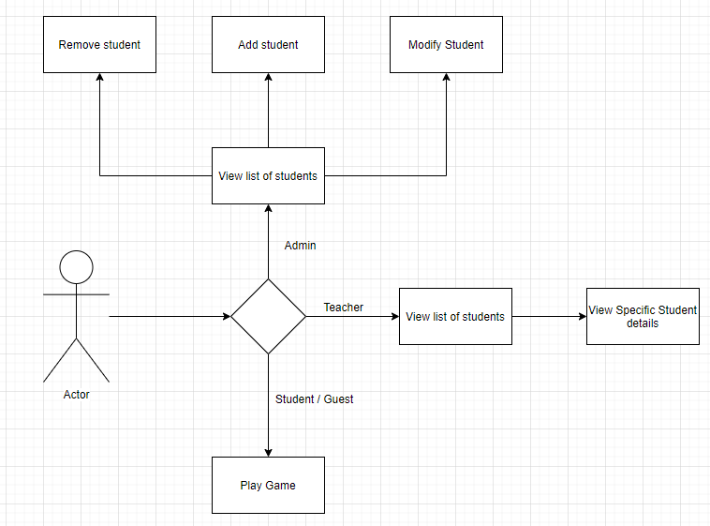

Teacher Use Case

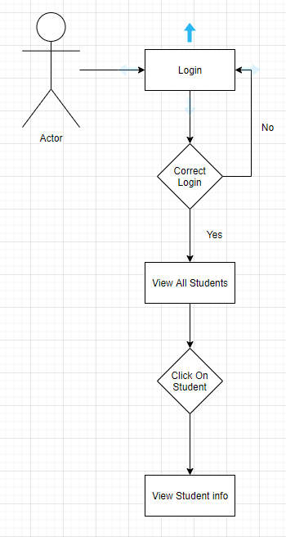

Student Use Case

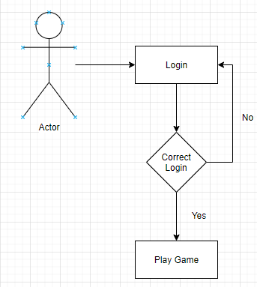

## UML Diagrams

This section will contain different UML diagrams of the different parts of the site.

## Data Base

The database will contain only the needed information about the users for the needed use. E.g. The date of birth of the user will not be stored as they will no need to be used anywhere. This will go for every user within the site. The database will be a MySQL database.

Each school will have their own table, this will allow the website to run more quickly than if every user from every school was stored on as one page. These tables will need to be created by an admin that has access to the databases as the website will not currently allow for databases to be created within it. This will be a future idea for the website. However, entering new students or staff members will be a feature that can be done through the website.

The login section will also need to use the same database, this will allow specific users to login with their ID and only be taken to the relevant pages, e.g. teachers will only see students from their schools.

## The Web Pages

This section of the document will talk about the different pages that are on the website, and how each of them work. I will also talk about how each of these links together through the navigation and who should be able to view each page.

### Login Page

The login page is the first page that the user will see. Unless you have the details to login, the website will not let you login

### Student Page

The student page is the page which the student will be taken to when they login

### Teacher page

The Teacher page is a page only the teacher and admin can see. This page will give a list of the teachers students. The page will give basic student information and the students score for the games they have completed.

## Testing

This section will talk about the testing that was done within the project and how the application was tested.

Originally the plan was to test this product with real people however, due to circumstances within the world, I though that it would have been better to just create a test table for each web page. Each section of the page will be tested for issues and then logged, with information about whether the issues where fixed or not.

## Related websites

This section will talk about other websites that offer similar experiences and activities to this website. The section will give details about the websites and score them against my opinion of the look and feel of the websites. The score will range from 0 to 10, ten being the best. The description of the website and opinion will allow me to score the website, while giving reasons for the websites scores.

TopMarks

<https://www.topmarks.co.uk/maths-games/5-7-years/counting>

I Find the website very difficult to look at, the site uses a lot of light colours but in my opinion, it just makes it look very untidy. The games however work well, and the website has a large category of games for a range of different ages. Having tablet based games is also a good thing to have

Score: 7/10

PrimaryGames

<https://www.primarygames.com/math.php>

This site doesn’t look as untidy as the TopMarks website however it does look a lot more boring, which when aimed at young people, it isn’t the best. I found that adds cluttered the page and some of the games did not work for me.

Score: 6/10

BBC

<http://www.bbc.co.uk/schools/websites/4_11/site/numeracy.shtml>

The look of this site is less cluttered than the PrimaryGames website. The page is easily navigable with descriptions of the games that show the age at which they are aimed at. The page however did not fit on my monitor well, it seemed to only take up half the screen. The page however does not receive updates as it has been archived by the owners

Score: 7/10

## GitHub

This is the link to my GitHub repository that I am saving my work to. This will allow me to keep track of any changes an allow me to use version control. I will also be using issues on GitHub to store the tasks that I need to do within the project. I will close off the tasks when they have been completed so that I know what needs to be done next

https://github.com/Rhod4/MMP.git

## Initial Annotated Bibliography

[1] Notepad-plus-plus.org. (2020). Downloads | Notepad++. [online] Available at: https://notepad-plus-plus.org/downloads/ [Accessed Feb. 2020]

[2] Atom. (2020). A hackable text editor for the 21st Century. [online] Available at: https://atom.io/ [Accessed Feb. 2020].

[3] Sqlitebrowser.org. (2020). DB Browser for SQLite. [online] Available at: https://sqlitebrowser.org/ [Accessed Feb. 2020].

((<https://datatables.net/>) table type being used in work)

((<https://www.valentinog.com/blog/html-table/>) help create the table implementation system for finding students)